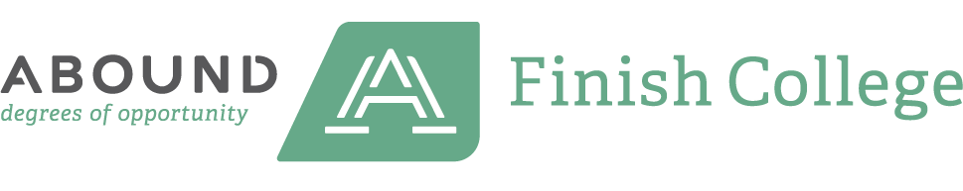

✅ Credit Transfer & PLA
Questions to Ask Before You Apply

🎓 Transfer Credit Questions
- What is your transfer credit policy?
(Are there limits on the number or age of credits?)

- Do you accept credits from my previous college(s)?
(Is regional accreditation required?)

- Will my credits apply to my intended major?
(Or will they count only as electives?)


- Do you have articulation agreements with other colleges?
(Especially in my state or region?)
- Can I get an unofficial transcript evaluation before applying?

🧠 Prior Learning Assessment (PLA) Questions
- Do you offer credit for work, military, or volunteer experience?

- What types of PLA do you accept?
  - CLEP or DSST exams
  - Portfolio assessment
  - ACE or military transcripts

- How many PLA credits can I earn?

- Is there a fee to complete a PLA evaluation?

- Do you provide support to help build a PLA portfolio?
(Workshops, templates, or advisors?)

✅ Pro Tip:
Always ask for a personalized transfer or PLA consultation—many schools offer this for free!

📌 Want to see which schools support adult learners?
Explore Abound’s Best Colleges for Adults and Best Online Colleges

